Reference Document

Receivables

Customer Add Process

Document Information

|  |  |
| --- | --- |
| Revision | 02 |
| Issued | June 01st, 2016 |
| Functional team | ERP Oracle Solutions |
| Document classification | GE Internal |
| Creator | Alberto Fernandez |
| Reviewer | Jeanne Moore |

Change Record

1

| Date | Author | Version | Change Reference |
| --- | --- | --- | --- |
|  |  |  |  |
| June 1st, 2016 | Alberto Fernandez | 1.0 | Initial Version including:   * New Template * Version Control * Complimentary Setups for Payor/Payee * Internal Location Definiton |
| February 27th, 2017 | Swagatika Samapika  Alberto Fernandez | 1.1 | Added screenshot on section 5.3 to illustrate Trading Partner |
| March 7th, 2017 | Alberto Fernandez | 1.2 | Added instructions to inactivate Customer Accounts and Sites as per Defect 13950 raised during NAM UAT |
| October 23rd, 2017 | Alberto Fernandez | 1.3 | Removed references from other businesses |

Reviewers

| Name | Position |
| --- | --- |
|  |  |
| Jeanne Moore | ESGAP Bill to Collect Lead |
| Amrutha Nair | ESGAP Bill to Collect IT Lead |
|  |  |
|  |  |
|  |  |
|  |  |
|  |  |
|  |  |

Distribution

| Copy No. | Name | Location |
| --- | --- | --- |
|  |  |  |
|  |  |  |
|  |  |  |
|  |  |  |
|  |  |  |

1. The copy numbers referenced above should be written into the **Copy Number** space on the cover of each distributed copy. If the document is not controlled, you can delete this table, the Note To Holders, and the **Copy Number** label from the cover page.

Contents

General 4

0. Gaining Access to MDM Customer Connect 5

1. Customer Search in MDM 7

1.1 Search by DUNS# 7

1.2 Search using address details 9

1.3 Search by Customer Name / Legal Entity 10

2. Adding a Customer to UNIFY 11

3. Logging into UNIFY (Receivables) 13

4. Finding Customer Record in UNIFY 14

5. Assigning Bill to and Ship to Relationships in UNIFY 17

6. Assigning Buyer/Seller Relationship in UNIFY 21

7. Add Customer Contacts 22

8. Add Reverse Charge Flag 25

9. Manual submission of Interface 28

10. Allowing Payments across different Legal Entities (Payor/Payee relationships) 32

11. Deliver To Addresses for Invoice Print Program 37

12. Internal Location and Internal Organization 38

13. Inactivating a Customer Site/Account 40

Open and Closed Items 43

# General

This is the process for adding an Internal and External, Bill to and Ship to customer into Oracle ERP.

User subscribes to the Customer Records in MDM and any changes made in MDM will automatically be updated in ERP. The process requires that the customer bill to and or ship to record already exist in MDM. Once the address has been verified as correct the record, the same can be subscribed.

Should the Record not be available in MDM then follow the Know Your Customer (KYC) process to add a new customer site record into Customer Master.

If the Record requires any changes then follow the process to update a Customer in MDM by completing the workflow.

Once completed, the process below under Customer Add Process may be used to bring that record into MDM.

Follow the process for each customer site in the order documentation that will

* Receive Invoices
* Receive goods
* Have services performed

# 0. Gaining Access to MDM Customer Connect

There are two options in order to gain access to Customer Connect:

Option 1:

* Open Service Request from Customer Connect, click on Create Help Ticket link

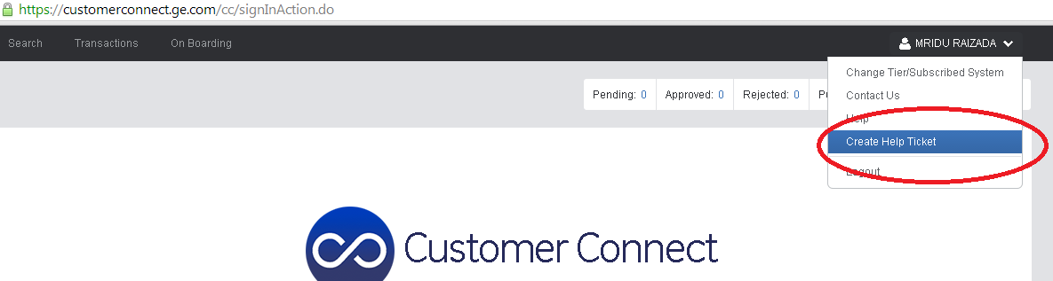

* It will open a screen for you to enter a Service Request for Enterprise Data Management – Customer Connect Portal

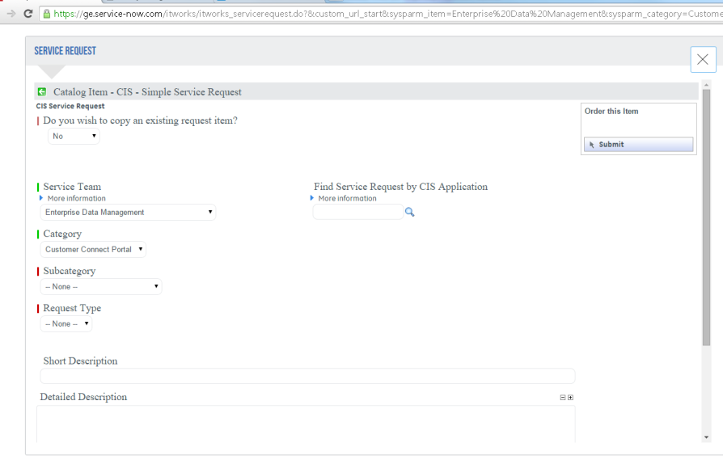

Option 2:

* Using Chrome (recommended browser) open the URL <https://ge.service-now.com/itworks/home.do>
* 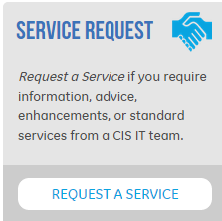Click on ‘Request A Service’ option
* On the form,
  + Select **Enterprise Data Management** as Service Team
  + **Customer Connect Portal** will auto populate
  + Select Access Request as the **Subcategory** from drop down

Once the access has been provided.

1. Go into Customer Connect Portal by following the url <https://customerconnect.ge.com>
2. Click on the button showing your name at the top section and select the option “*Change Tier/Subscribed System*”

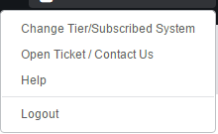

1. On the next Form, select the following values:

Tier 1: Power

Tier 2: Headquarters

Subscribed System: UNIFY

1. Click on Submit button

# 1. Customer Search in MDM

**For SIT and UAT Please use the below link and login**

[**https://stage.customerconnect.ge.com**](https://stage.customerconnect.ge.com)

**This is an SSO enabled application.**

Search for Customer in Customer Master File

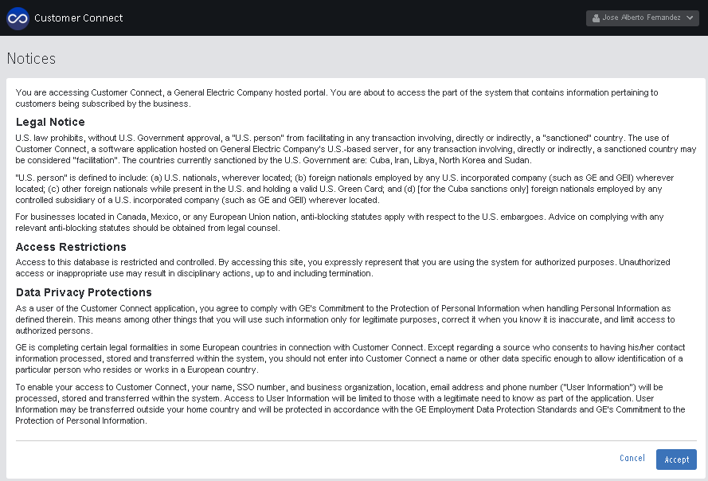

There are three basic filters that may be used to search for a Customer:

* DUNS #
* Customer Address
* Customer name / Legal Entity

## Search by DUNS#

Type in the DUNS # in the “Customer Legal Name or DUNS Number” field and click “Next”. The DUNS # is a 9-digit number

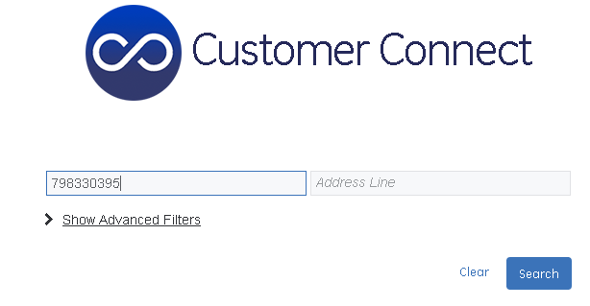

Once the DUNS# has been found, the Customer details are displayed

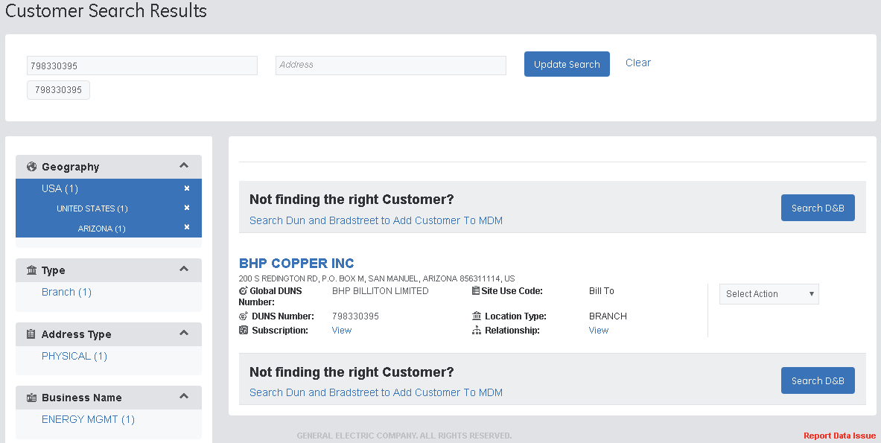

## Search using address details

Type in the Customer address as it appears on the Order documentation and click “next”.

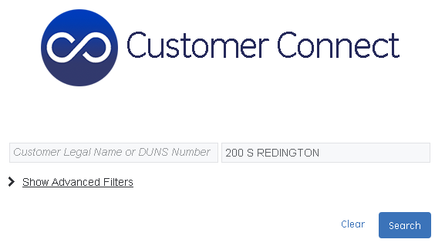

All Customers in MDM that contain part of the address details in the search will now be shown. Select the required Customer.

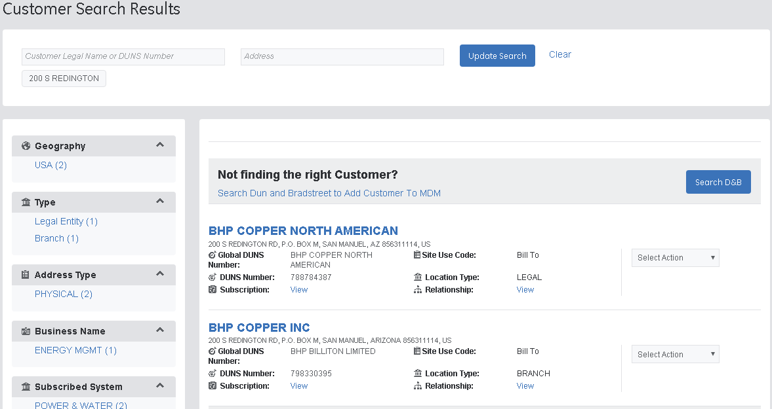

## Search by Customer Name / Legal Entity

Type in the Customer Name as it appears on the Order documentation in the “*Customer Legal Entity Name or DUNS Number*” field and click on “Search”

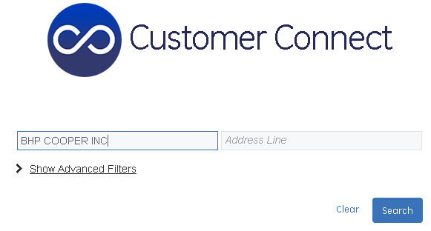

# 2. Adding a Customer to UNIFY

* 1. From the “Customer Search Results” page, select the desired customer from the list ensuring that the address matches the Order documentation. Click “Select Action” dropdown menu and then click on Subscribe.

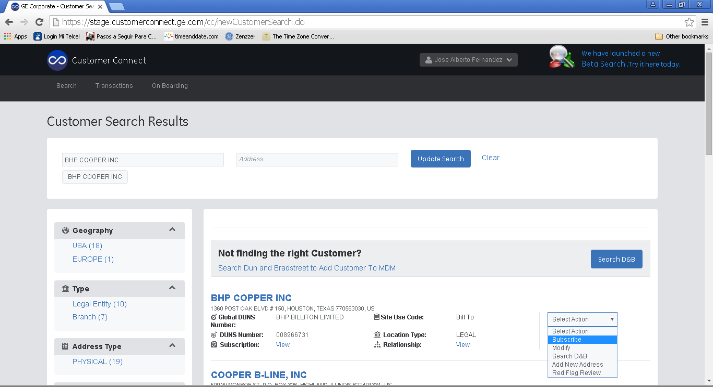

* 1. Select UNIFY from Customer Subscription Pop up screen.

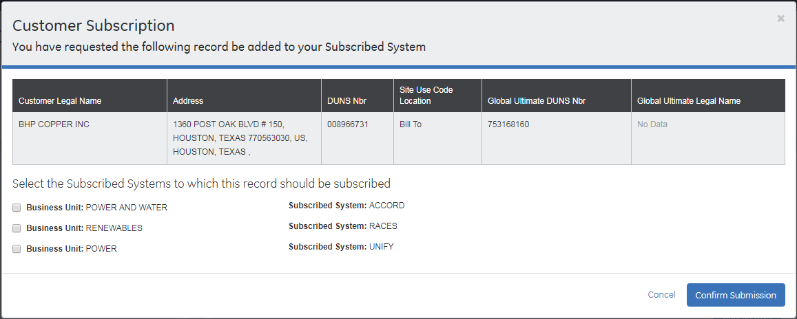

* 1. Select the Operating Unit where the customer record is required and click in “*Submit”* button

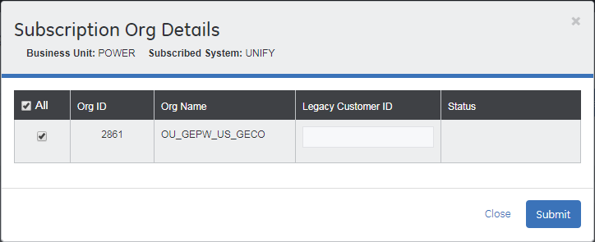

Click “Confirm Subscription” button.

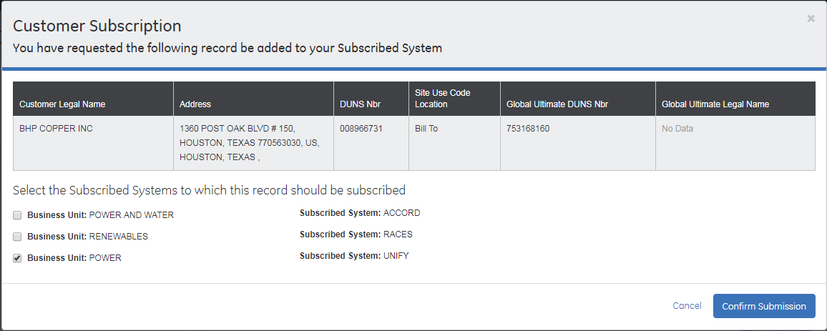

Subscription Confirmation will be shown next

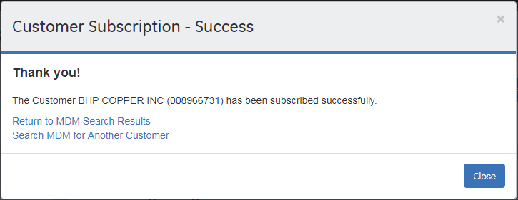

* 1. The added Customer will take 5 minutes to be sent to UNIFY ERP. (The entire add process should not take more than 10 minutes).

# 3. Logging into UNIFY (Receivables)

* 1. Login to Oracle <https://uniformqa1.pw.ge.com/>
  2. You will need *GERE AR Customer Maintenance* access to search and or view customer records.

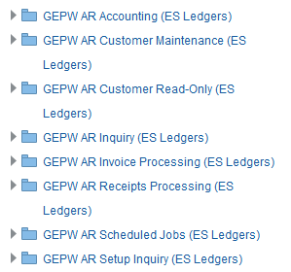

* 1. Select Customers from the main menu, then select Customers again to launch the Receivables Customer Management screen

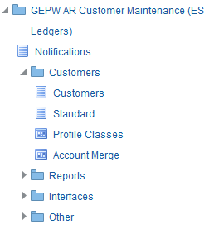

# 4. Finding Customer Record in UNIFY

4.1 Search for the customer in UNIFY

This may be done by:

* Typing in the Customer Legal Entity in the Customer field and then click “Go”. You can use part of the Customer Legal Entity name followed by “%” in the Customer field and then click “Go”

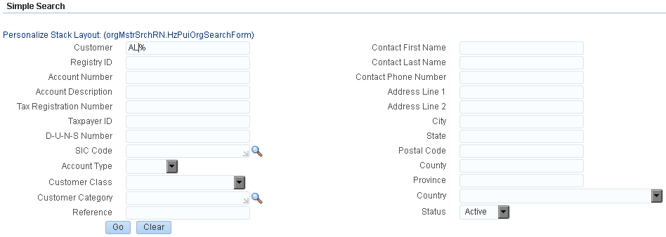

* This will now bring up a list of customers names that start with “AL”

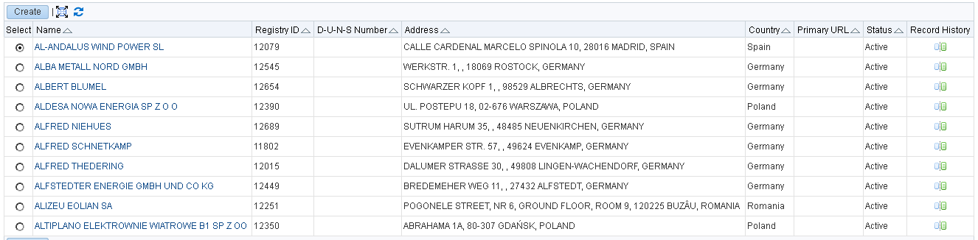

4.2 Click on the required customer name

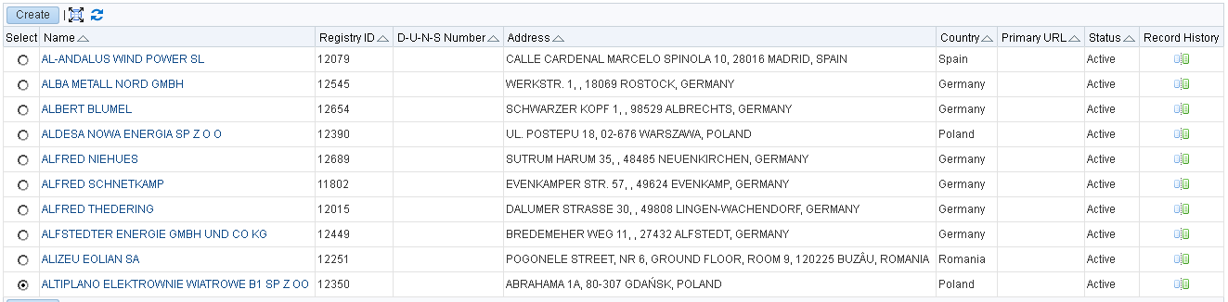

4.3 Scroll down to Accounts section and click on Details. Next screen will show the different sites created under that particular Account for the Operating Unit defined by the responsibility you are using:

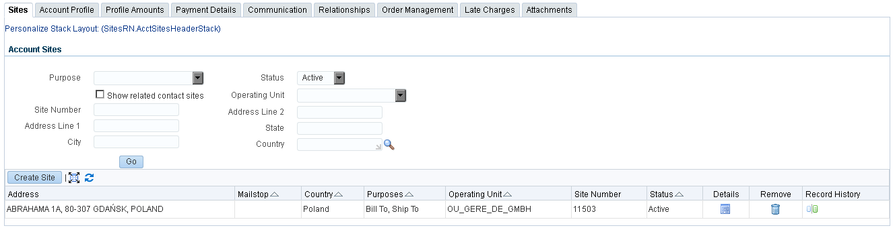

4.4 Click on “Details” to get to the specifics of the particular site

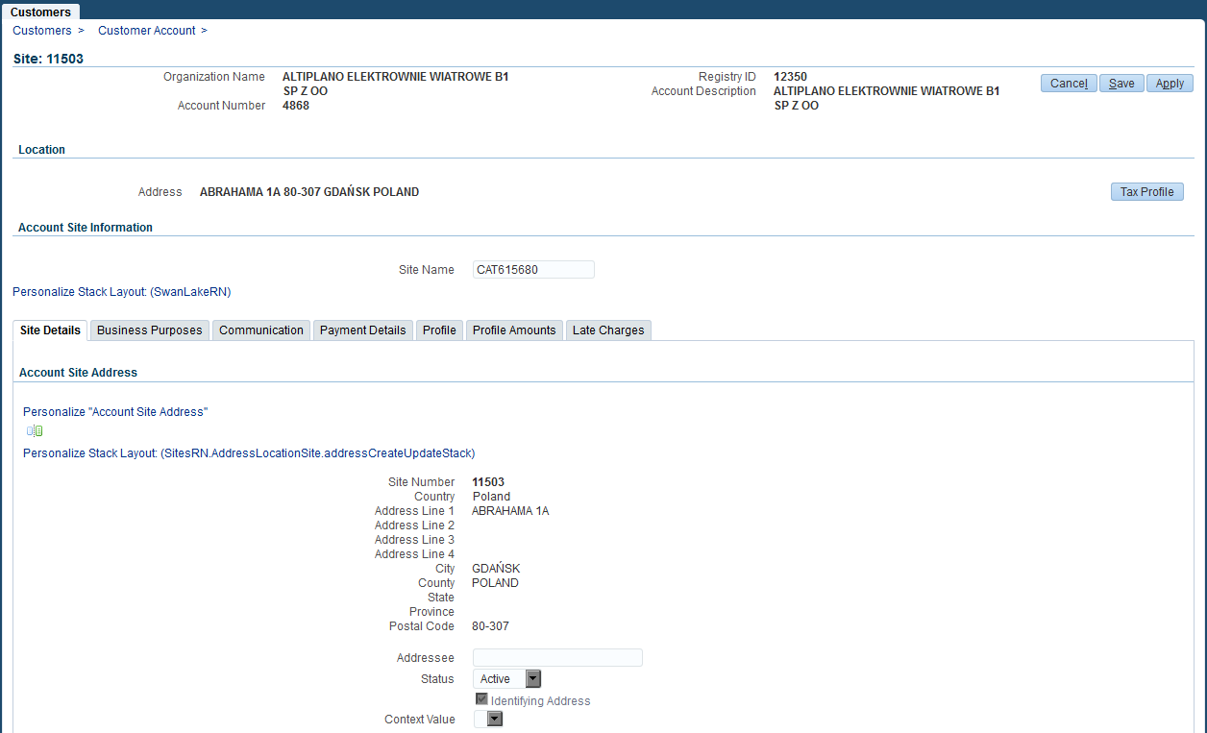

4.5 Billing Settlement System will be found in “Account site details” section

4.5.1 The field will be derived during Customer load as

* GECARS if Customer is classified as EXTERNAL
* IBS if Customer is received as INTERNAL

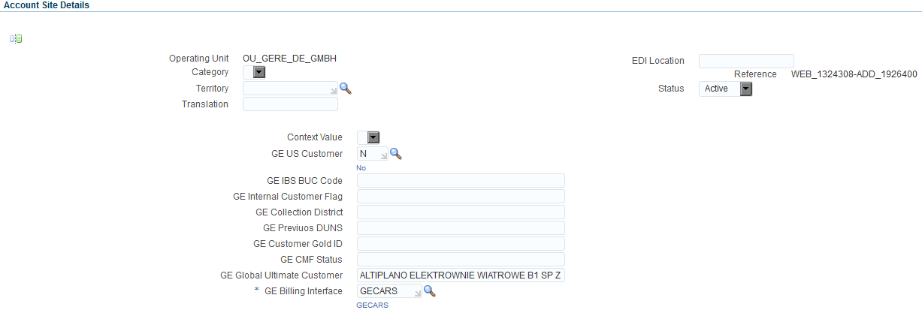

4.5.2 Other fields to validate for Internal Customers are also available in this section.

* IBS BUC CODE
* Customer GOLD ID
* Trading Partner

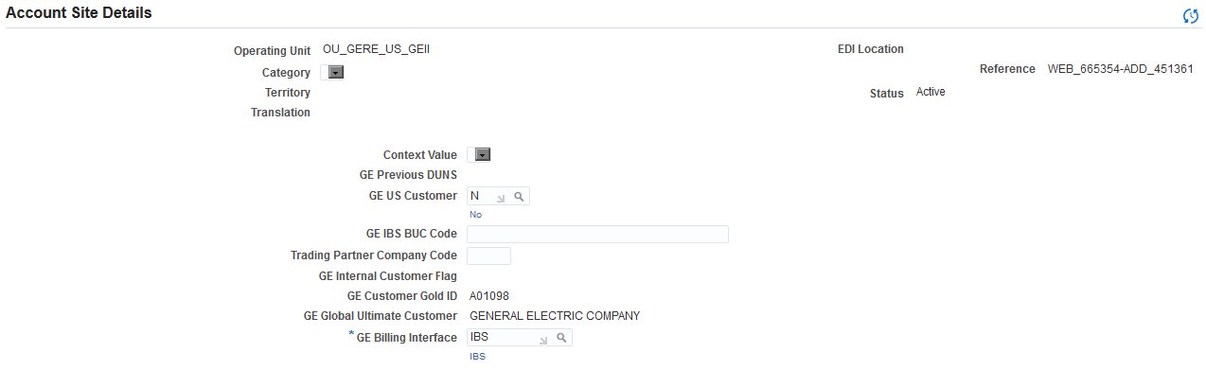

# 5. Assigning Bill to and Ship to Relationships in UNIFY

* 1. The customer Relationship (Bill to and Ship to) will need to be set manually for all Internal and External Customers if two different accounts need to be used in the same transaction. The same process is followed whether the Customer is Internal or External.
  2. Search for the Bill to Customer by logging into UNIFY and selecting Customer, then Customer again from the Main Menu.
  3. Search for the required Customer by typing in the customer name and clicking “Go”.

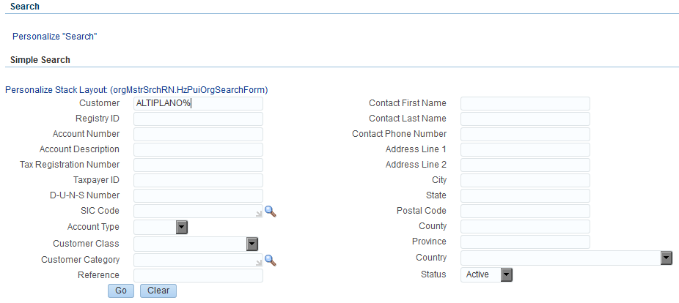

* 1. Scroll down to Accounts and click on “Details”. (The section under “Accounts” will always only show the records related to above entered criteria, similarly the section under “Sites” will only show the sites for the picked account under current Operating Unit).

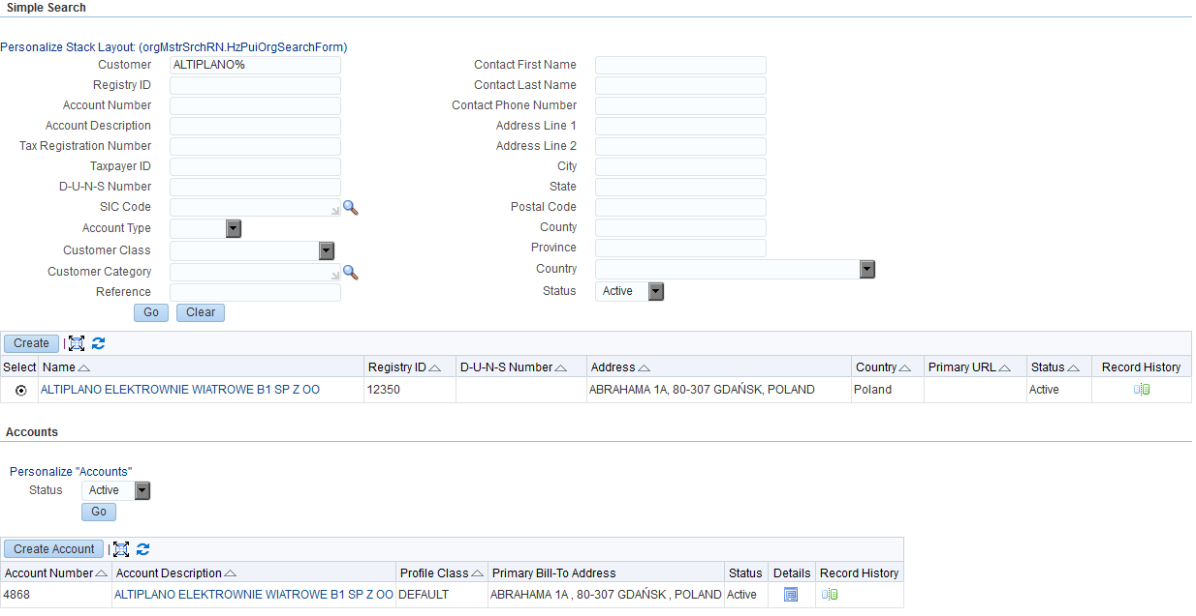

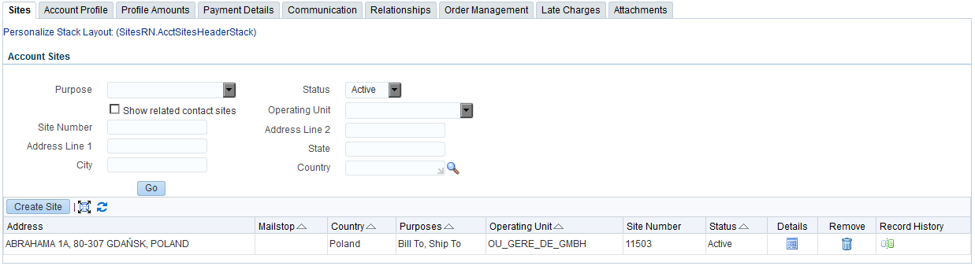

* 1. Click on “Relationships” tab



* 1. Click on “Create Account Relationship”

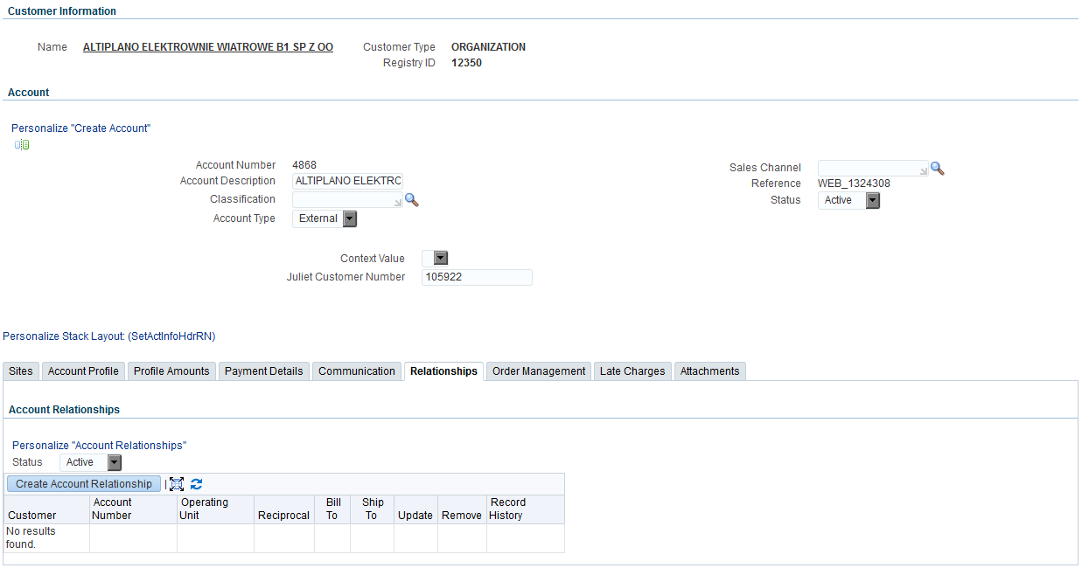

* 1. Search for the Related customer by clicking on the magnifying glass

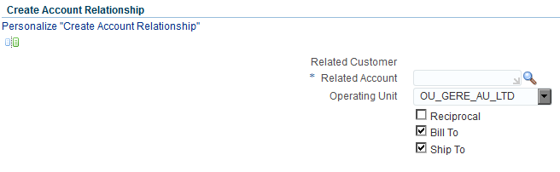

* 1. Search for the required customer by Customer or Account

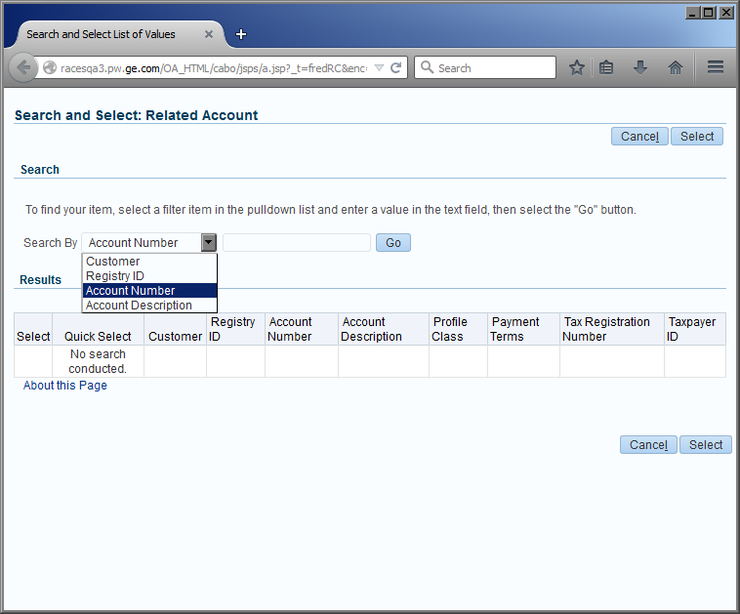

* 1. Type in the required search information in the field and click “Go”

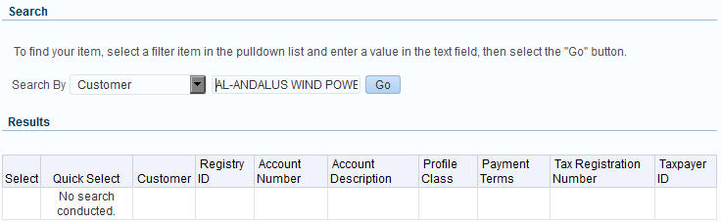

* 1. Select the related customer by clicking on the field under select and then click “Select” at the bottom of the screen

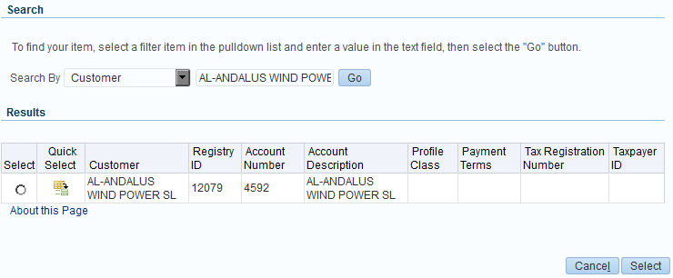

* 1. Select the required Operating Unit (Only 1 operating unit may be selected at a time). Click on the downward arrow to see list of Operating Units. Select the appropriate relationships. Once the relationship has been selected a tick will display in the box next to it. Below example shows Reciprocal, Bill To and Ship To relationship. Then click “Apply”.

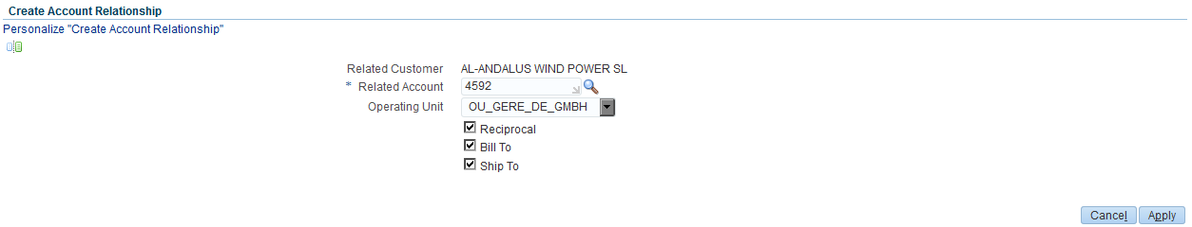

* 1. The Customer record will now show the account relationships as shown below. Click “Save”.

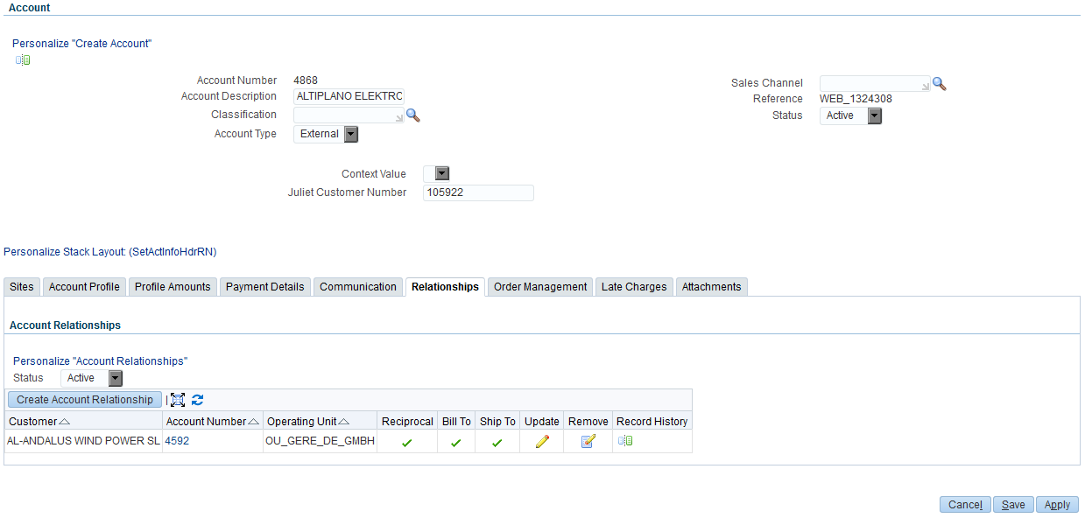

* 1. A Customer could have more than 1 Bill To and Ship To relationship with more than 1 Legal Entity. If that is the case these will be added in the same way as above.

# 6. Assigning Buyer/Seller Relationship in UNIFY

* 1. Login to RACES. Select Customer and Customer again. (as in Point 1 – 3 above)
  2. Search for customer (as described in topic *4. Finding Customer Record in UNIFY*).
  3. Select required customer and required Operating Unit then click on “Details”

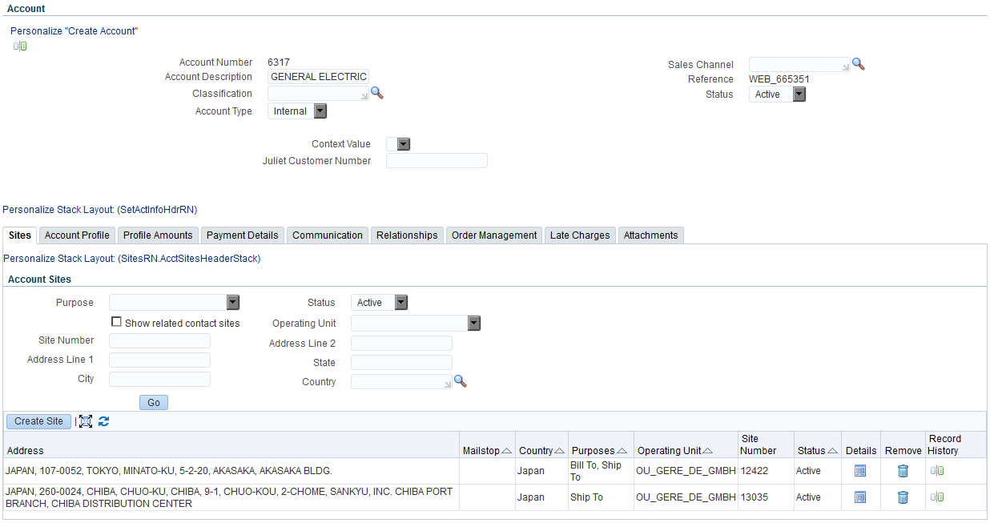

* 1. Please ensure that the billing Interface has been selected. You will not be able to set the Buyer / Seller Relationship until this has been done.
  2. Click on “Business Purposes” tab.
  3. Pick the Bill To Purpose and type the GE Customer Relationship. You can also use the magnifying glass to search for the value.

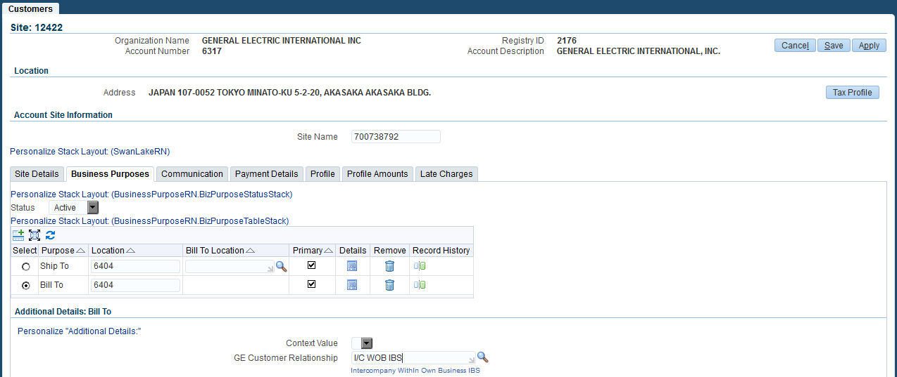

# 7. Add Customer Contacts

* 1. Contacts might be required to be added to Customer records. Examples of some of the Customer Contact information which may be stored include Bill-To Contact, Ship-To Contact, Customer Project Manager Name and Contact Telephone number and email address.
  2. Log into UNIFY and select Customer, then Customer again from the Main Menu.
  3. Search for the required Customer by typing in the customer name and clicking “Go”

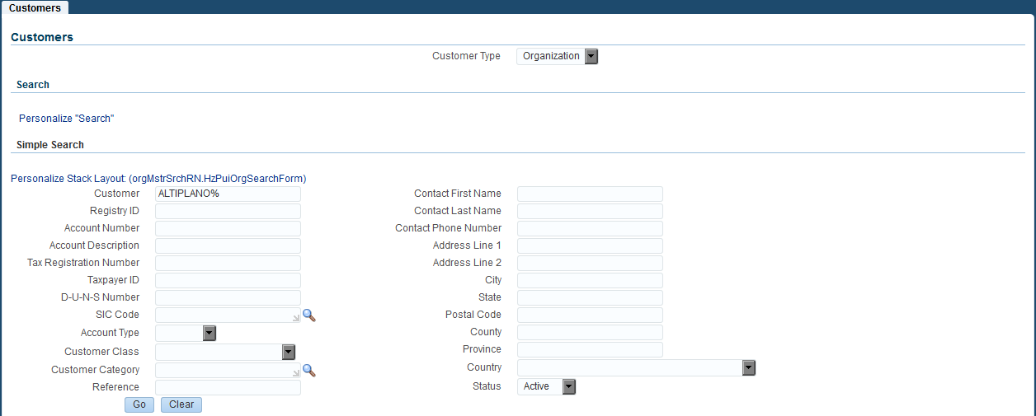

* 1. Select the Site and Operating Unit to which you want to add the Customer Contact Details, Under Create Site. Then click on “Details”.

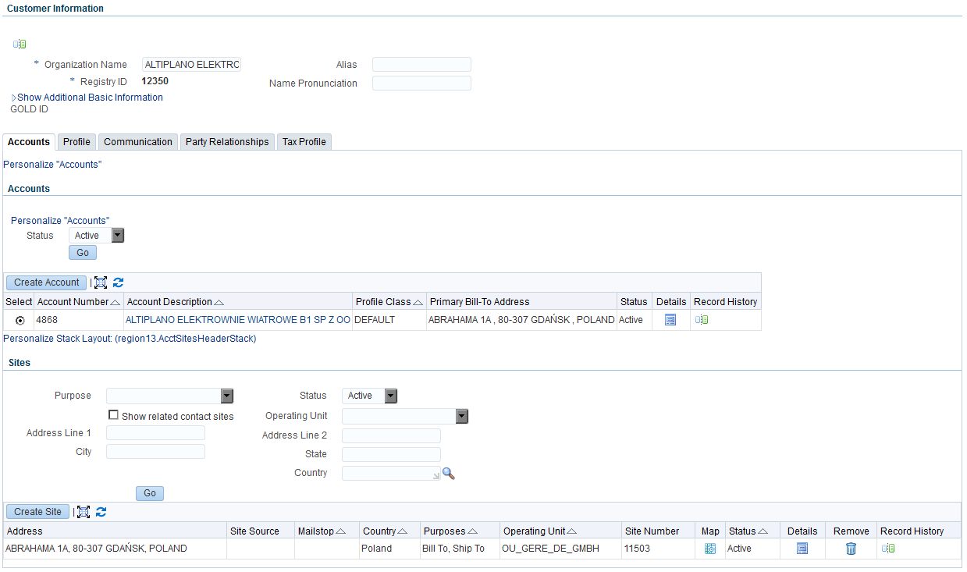

* 1. On the next screen click on the “Communication” tab.

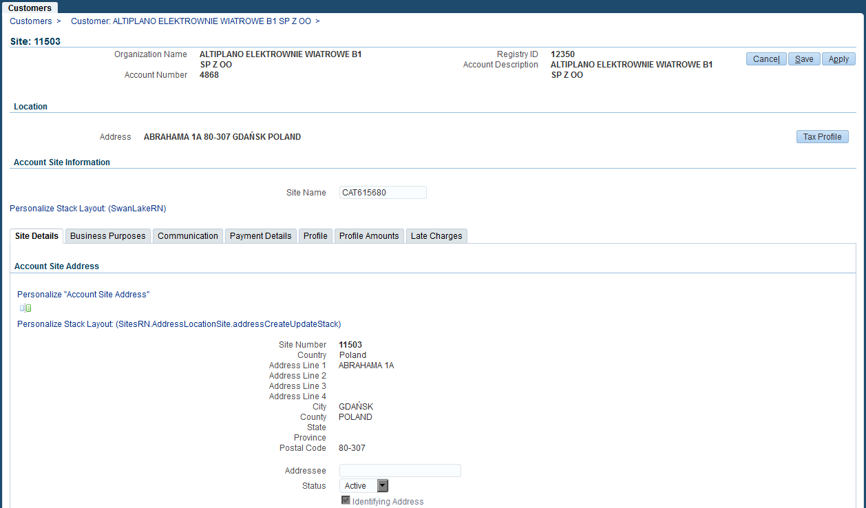

*NOTE: Billing Interface field is a required one if it is blank you will not be able to navigate away from this page.*

* 1. Under Site Contacts click on Create Contact.

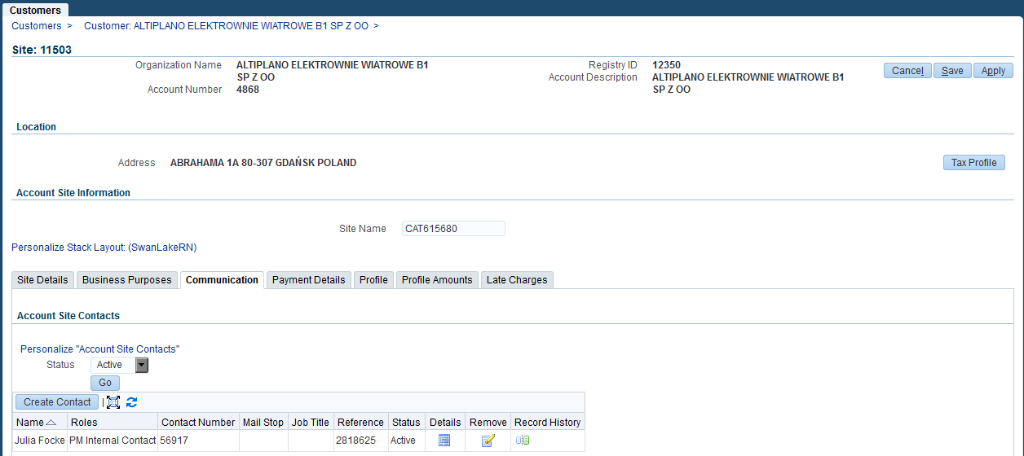

* 1. Now complete the below fields with the relevant contact information, then click “Apply”. Please note the mandatory fields are: Name, and Address1 on Physical Address
  2. The contact details will now be shown. See below. You may add as many contacts as you require by following the same process. You may also remove contacts by clicking the “remove” button.

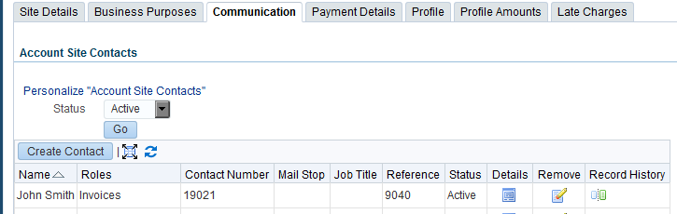

* 1. If contact details are no longer required then you may remove contacts by clicking the “remove” button.



* 1. You will then receive a screen that asks if you are sure you want to remove this site contact. Click Yes.

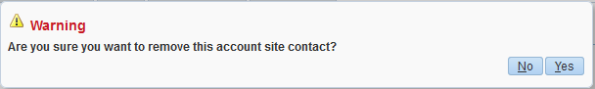

# 8. Add Reverse Charge Flag

Sometimes a special Tax treatment is required for certain customers, those customers are identified by a flag called *Reverse Charge Flag,* which can be set at Header Level (When it applies for all the sites for this customer) or at Site Level (when this needs to be applied for specific sites only). Steps to be followed to set this flag at both levels are detailed in this section

* 1. Header (Customer) Level
     1. Log into UNIFY and select Customer, then Customer again from the Main Menu.
     2. Search for the required Customer by typing in the customer name and clicking “Go”



* + 1. Scroll down to the Party section and click on customer name that needs to be updated.



* + 1. Once in *Customer Information,* click on Tax Profile Tab, check the box for “*Set for Self Assessment / Reverse Charge*” and save changes

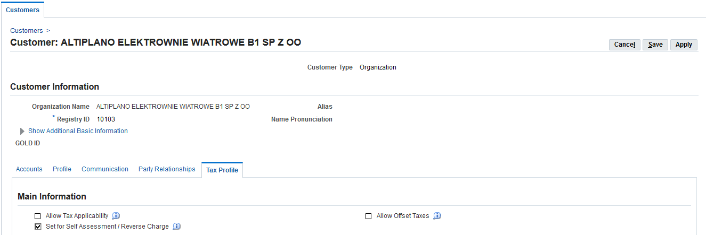

With this, the flag will apply for all Sites under this customer

* 1. Site Level setup
     1. Search for the required Customer by typing in the customer name and clicking “Go”



* + 1. Select a Party and scroll down to Account Results, click on details on the desired Account.

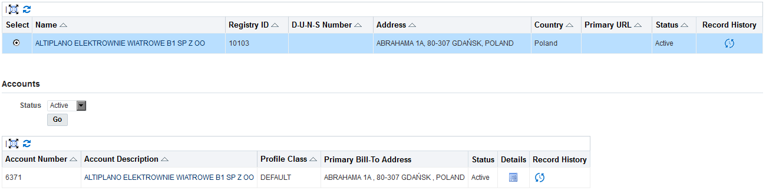

* + 1. Scroll down to Account Sites section, click on Details on the site that need to be updated.

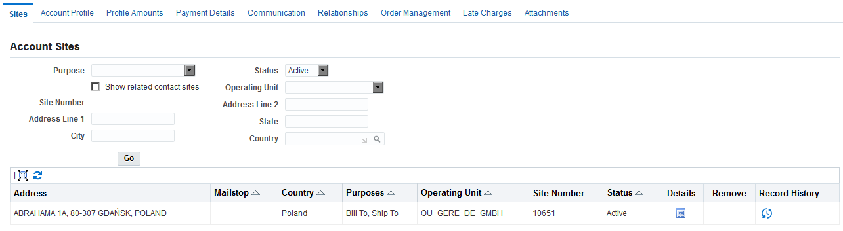

* + 1. Once in Site Details section, click on Tax Profile button

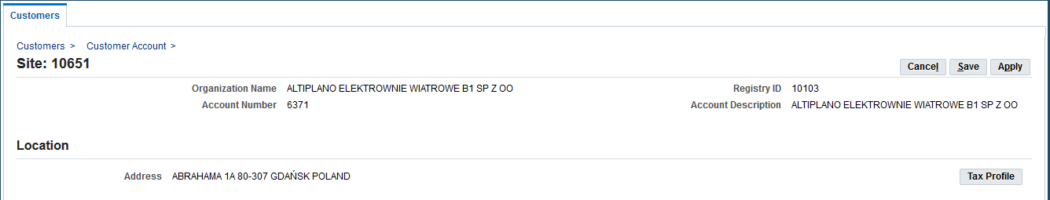

* + 1. Check the box for “*Set for Self Assessment / Reverse Charge*” and save changes

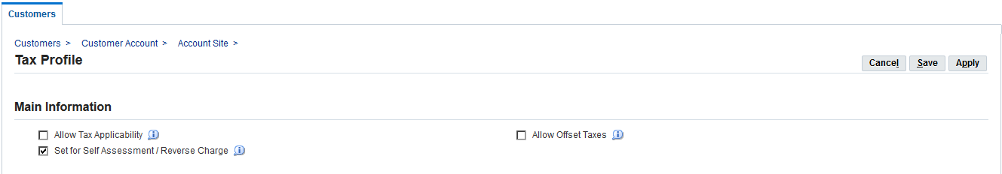

# 9. Manual submission of Interface

There will be a schedule request of interface by Operating Unit in UNIFY production instance. However, if required a manual execution can be submitted by following the below steps.

* 1. From any AR Customer Maintenance responsibility, go to Other > Request > Run option in the menu

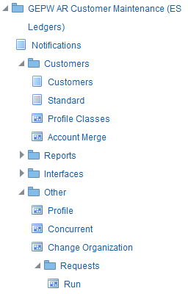

* 1. On the form that will be open next, select *Request Set* and click Ok.

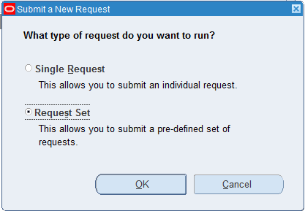

* 1. On Request Set field, select “GES MDM to AR Inbound Request Set”
  2. Click on Parameters for first program “GES MDM to AR Interface” and determine the values to be used for:

*Org ID*: Operating Unit for which you want to run the program for. This is an optional parameter and a list of values is available on the same.

*Email ID*: e-mail address that will receive the validation report for the processed records.

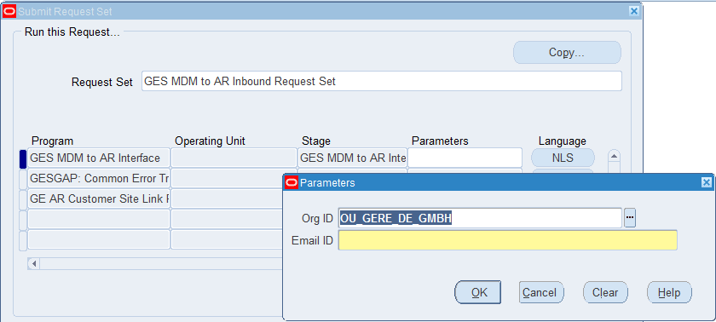

* 1. Click on Parameters for third program “GE AR Customer Site Link Program”. This program will assign the primary BillTo to the ShipTo Sites. This program generates an output to show the values to be set on the considered Accounts and Sites.

*Org Name*: Operating Unit for which you want to run the program for. This is an optional parameter and a list of values is available on the same. Optional value

*Report Only*: If set as N the program will proceed and create the relationships, otherwise it will just show the values found for each of the identified sites.

*Customer Account From*: This parameter can be used to narrow the execution of the program, this is the starting point for customer account range.

*Customer Account* To: This parameter can be used to narrow the execution of the program, this is the ending point for customer account range.

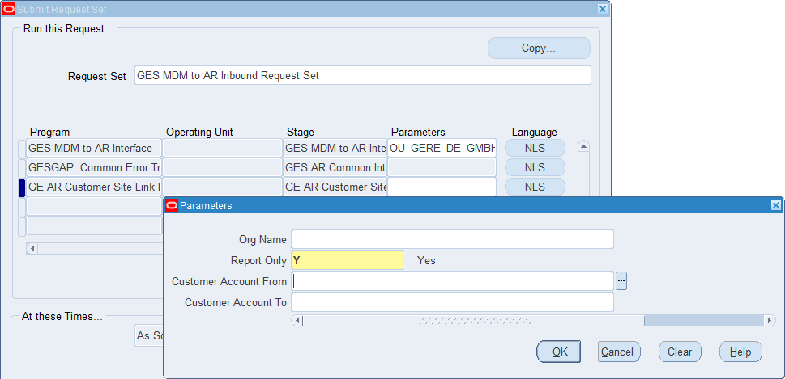

* 1. Once the parameter values have been entered, click on Submit button. A pop-up window will be display, the same will inform the Request Id generated for this submission, click on No while asked to run another program

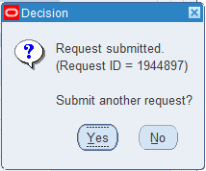

* 1. Click on View menu, then select Requests option and click on Find button, this will take you to the Standard Requests window

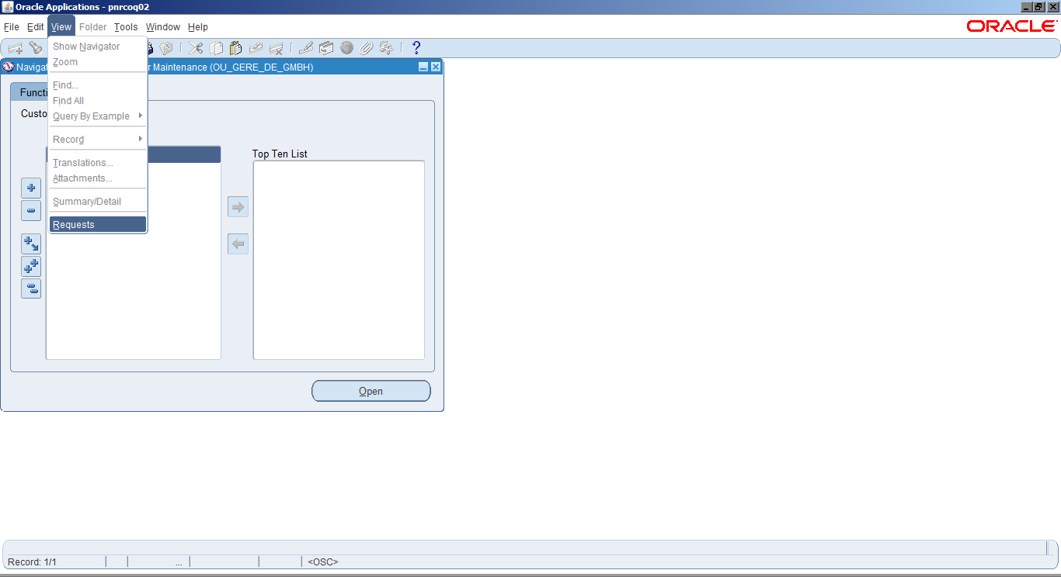

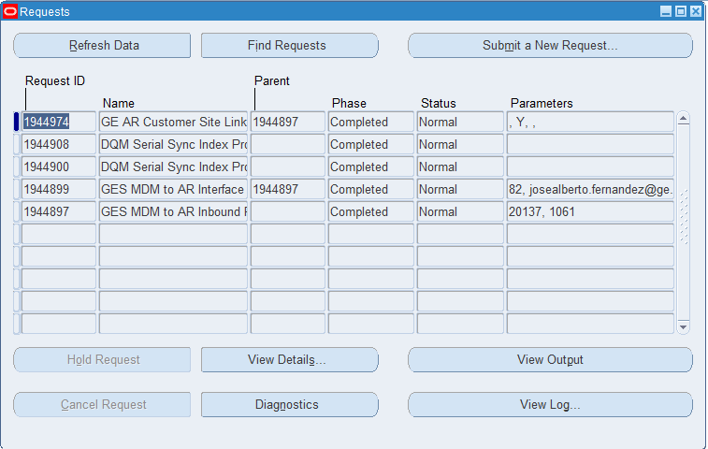

* 1. Output for ‘GES MDM to AR Interface’ program would show all customer data which have been created and error out along with error details. Select this program and click on View Output button, a new browser tab will get open showing a report like this:

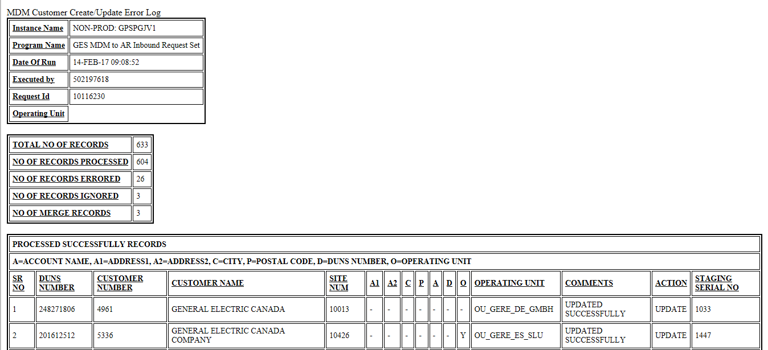

* 1. Output for GE AR Customer Site Linkage Program will show the values that were used to link the ShipTo with corresponding Bill To locations. Select this program and click on View Output button, a new browser tab will get open showing a report like this:

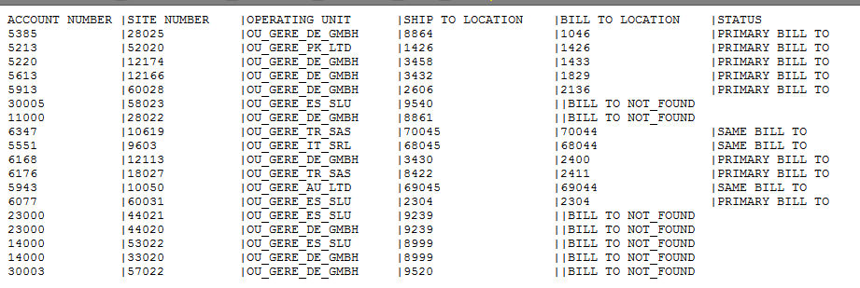

* 1. Once the main program has finished, an email will be received by the recipient specified in point 4 above. The same will contain an excel file showing the total count of records processed. The email will look like this:

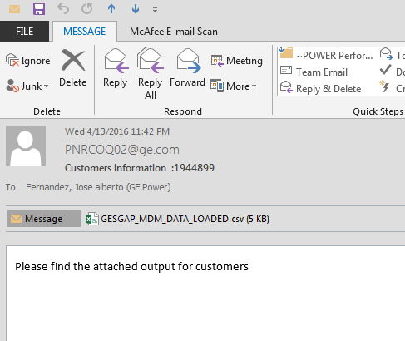

# 10. Allowing Payments across different Legal Entities (Payor/Payee relationships)

Under certain circumstances it is expected to have a customer account making payments on behalf on another one. This is something that is allowed in GECARS and can be replicated in UNIFY to keep track of what GECARS is having. The steps required for this are the following:

* 1. Search for one of the Customers to be related. Please refer to section 4 “*Finding Customers in RACES”*.
  2. Once the Customers have been listed, click on desired Party Name from Results Section.

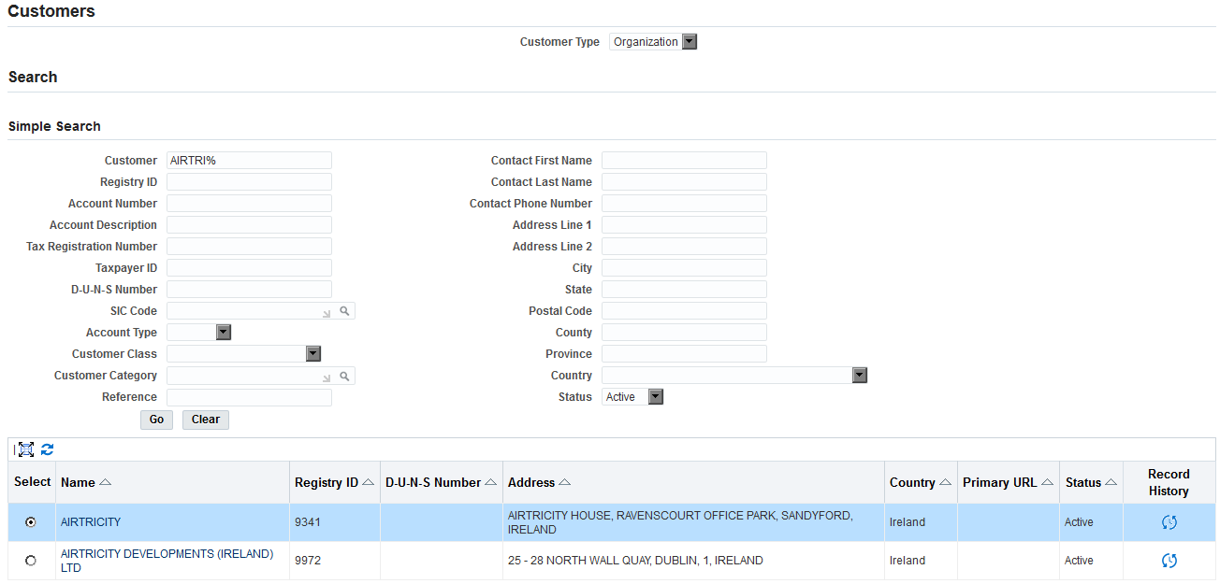

* 1. Once in Customer Section, click on *Party Relationships* Tab and click on Add another row button

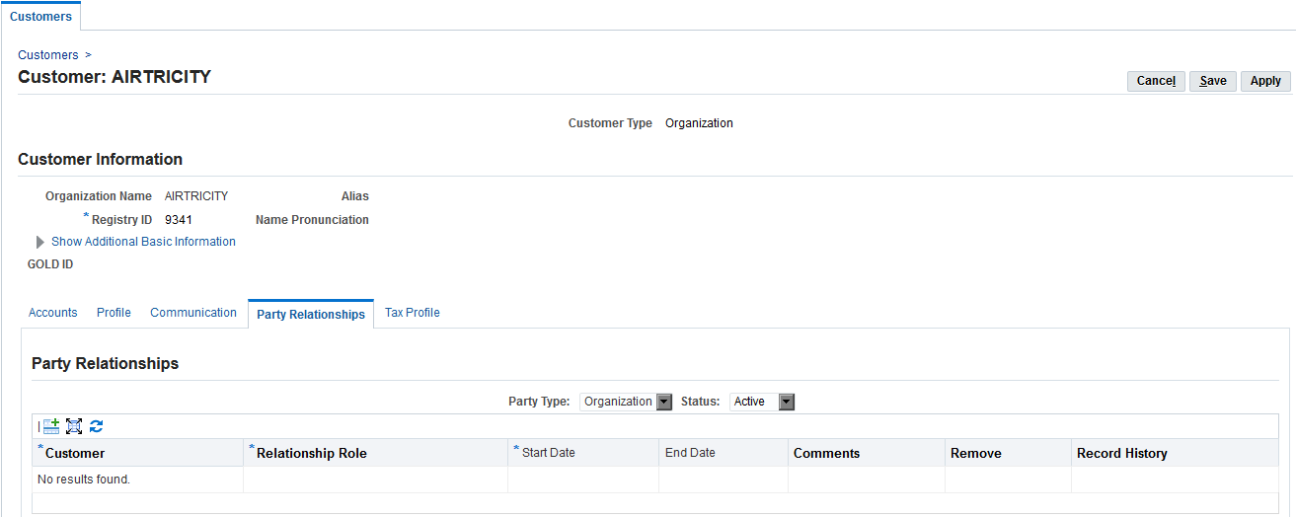

* 1. Enter Customer Name, Relationship Role and optionally some comments about the relationship. 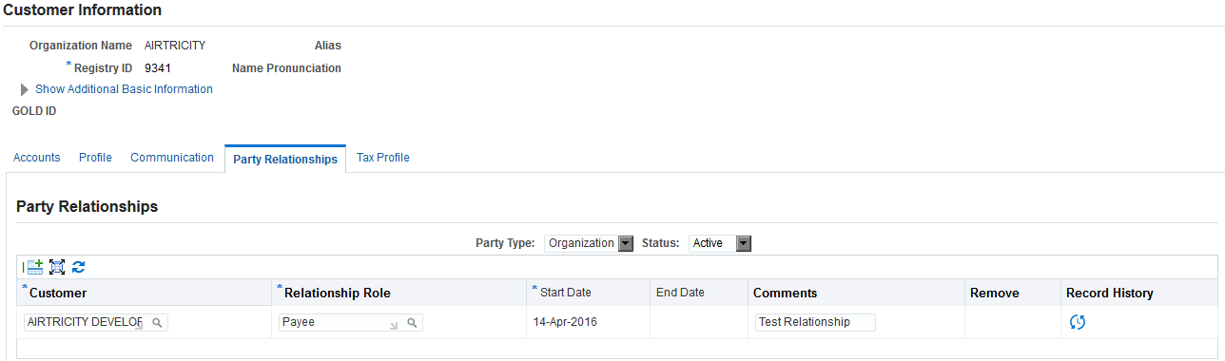

NOTE: In the above screenshot, Customer AIRTRICITY DEVELOPMENTS (IRELAND) LTD is being defined as a Payee of Customer AIRTRICITY, meaning AIRTRICITY can do payments on behalf of AIRTRICITY DEVELOPMENTS (IRELAND) LTD.

* 1. Save the changes.

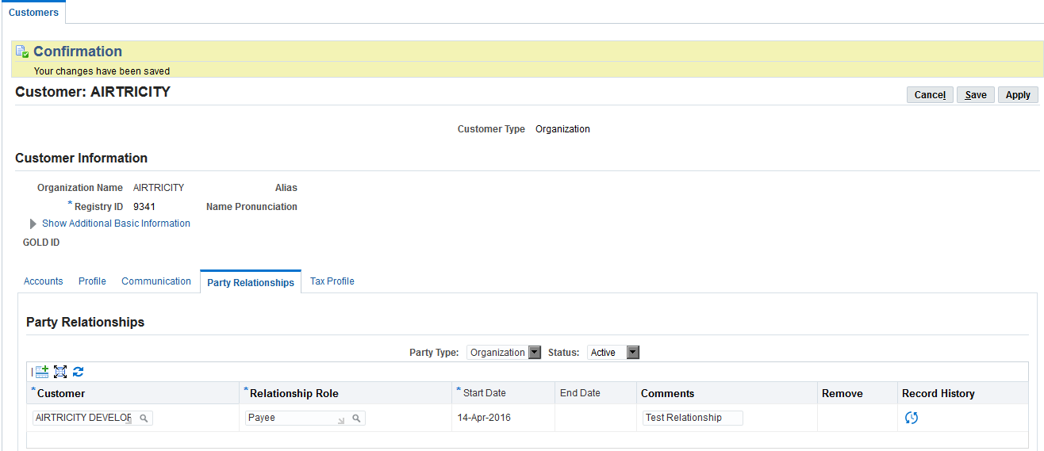

* 1. Click on cancel buton, this will take you back to the Customer Results page.
  2. Scroll down to Accounts and click on “Details”.

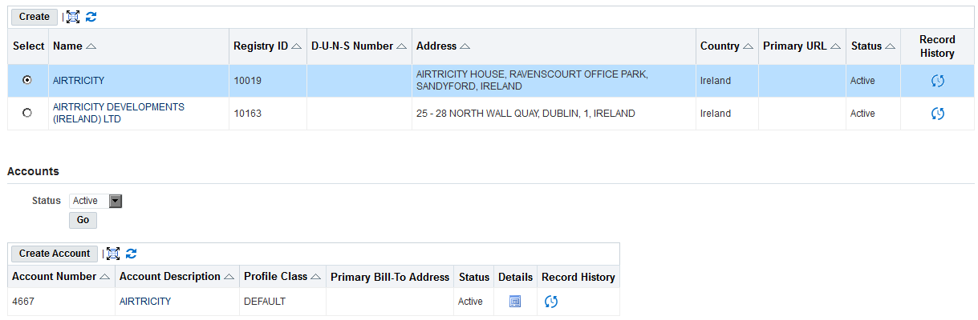

* 1. Once on the Account level, click on “Relationships” tab



* 1. Click on “Create Account Relationship”

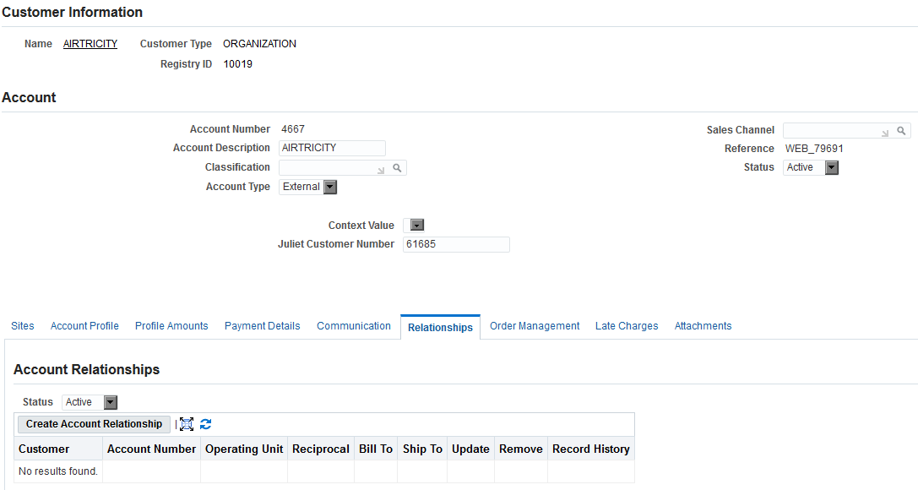

* 1. Search for the Related customer by clicking on the magnifying glass.



* 1. You can do Search for the required customer by Customer or Account



* 1. Type in the required search information in the field and click “Go”. AIRTRICITY DEVELOPMENTS (IRELAND) LTD as per the illustrated example

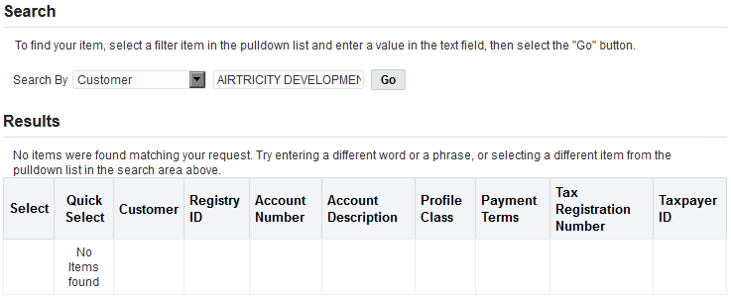

* 1. Select the related customer by clicking on the field under select and then click “Select” at the top of the page

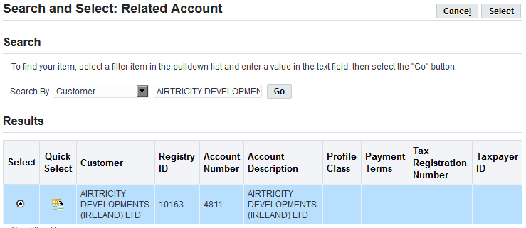

* 1. Select the required Operating Unit (Only 1 operating unit may be selected at a time). Click on the downward arrow to see list of Operating Units. Select the appropriate relationships. Once the relationship has been selected a tick will display in the box next to it. Below example shows Reciprocal, Bill To and Ship To relationship. Then click “Apply”.

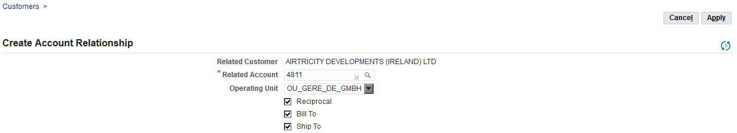

* 1. The Customer record will now show the account relationships as shown below. Click “Save”.

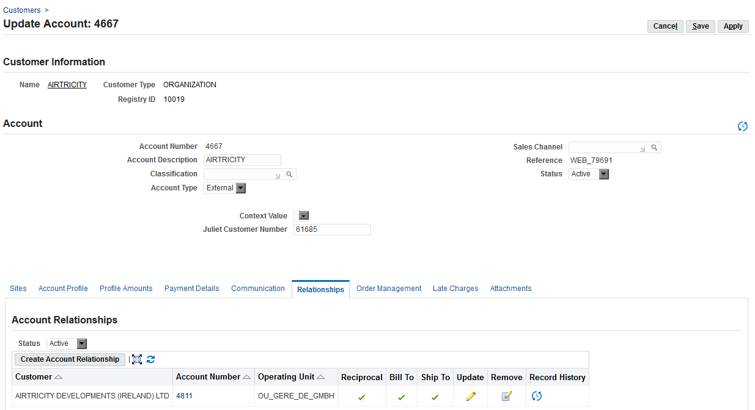

# 11. Deliver To Addresses for Invoice Print Program

11.1 Deliver To addresses are now required to be stored as Contacts on the specific sites where those are located. Process is similar to the one described in Section “Add Customer Contacts”. The difference is basically around the values to be used for following Fields:

|  |  |
| --- | --- |
| **Field** | **Description / Value to be used** |
| Last Name | Enter Legal Entity Name as this is a required field; this will not be shown on Invoice Print |
| Address | This will be the address where invoice needs to be sent |
| Role | Scroll down to the bottom of Account Site Contact page, and under Contact Roles Section use the Add another Role button to add *Deliver To* |
| Primary | Check the Primary flag for this Role |

11.2 Once the above fields and Roles have been entered, click on *Save* button

# 12. Internal Location and Internal Organization

For internal requisition deliver-to locations, you will need to associate the inventory locations with an Internal customer. Within an Operating Unit, a location can only be designated as a Ship-To Internal Location for a customer once. Another customer within the same operating unit can no longer use the same location as a Ship to Internal Location. However, a customer in another operating unit can.

12.1 Search the Customer that you need to relate to the Internal Organization

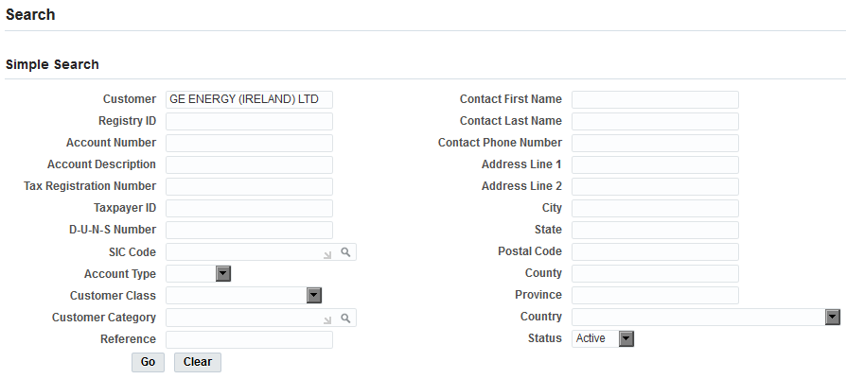

12.2 Select the Customer from Results and then click on Account Details

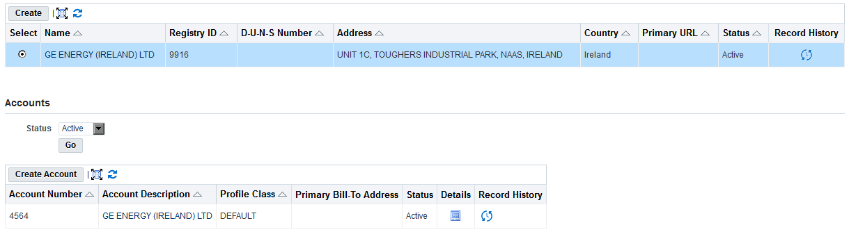

12.3 Open the details for the required Site.

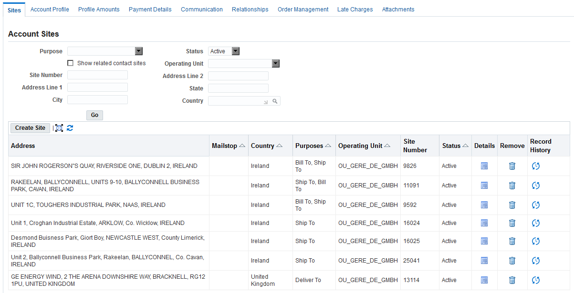

12.4 Click on Business Purposes Tab

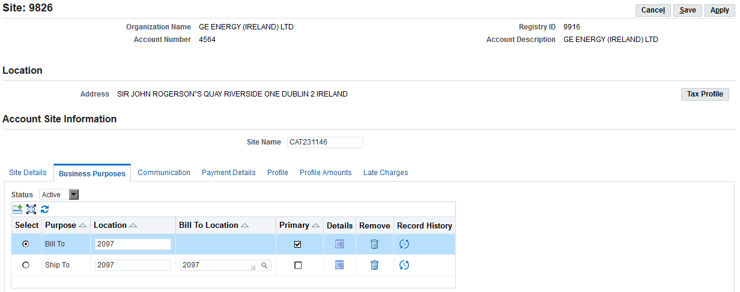

12.5 Select the Ship To Purpose and Click on Details

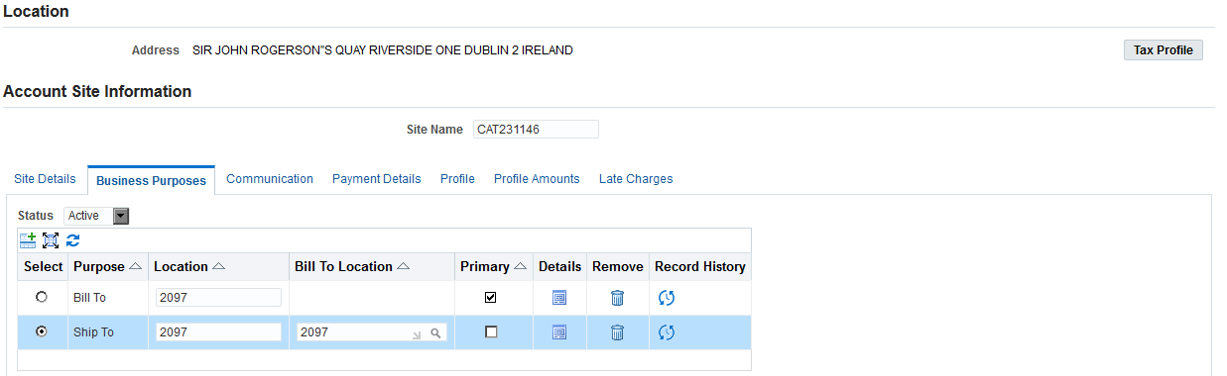

12.6 On next screen, enter the required values for Internal Location, Internal Organization and click on Apply

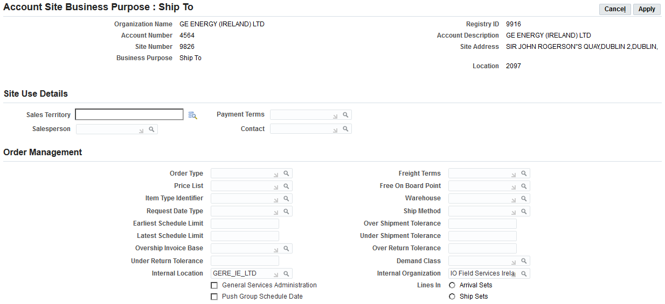

# 13. Inactivating a Customer Site/Account

When inactivation records are published by MDM, these are only notified on Customer Confirmation Report but not automatically processed. When this happens, a manual inactivation is required to be performed in RACES ERP. Below are the steps required to do this:

13.1 Site Inactivation

13.1.1 From Customer Maintenance responsibility, search the customer for which you want to inactivate a site

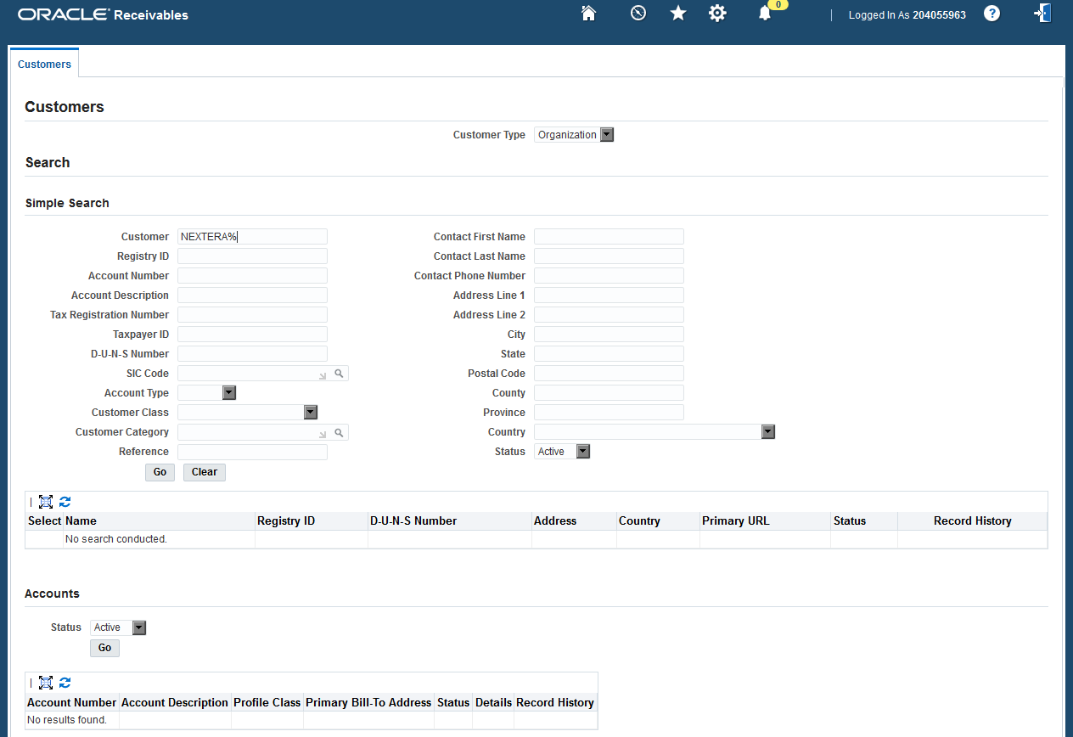

13.1.2 Once in the Results page, scroll down and select the desired account and click on Details at the account level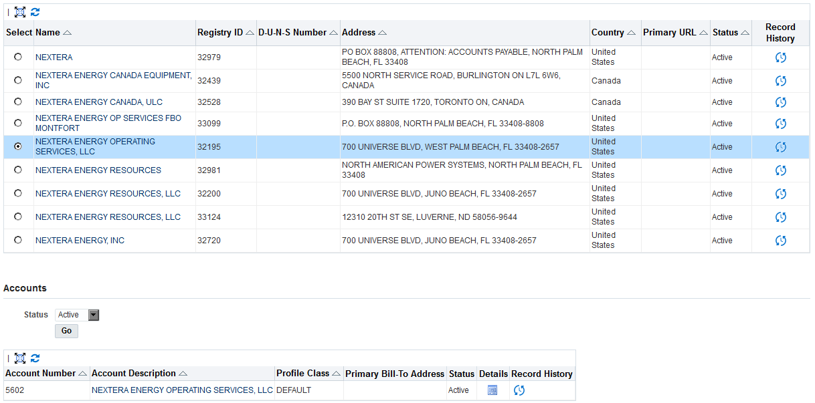

13.1.3 Once at the Account level, click on Details for the Site you want to inactivate

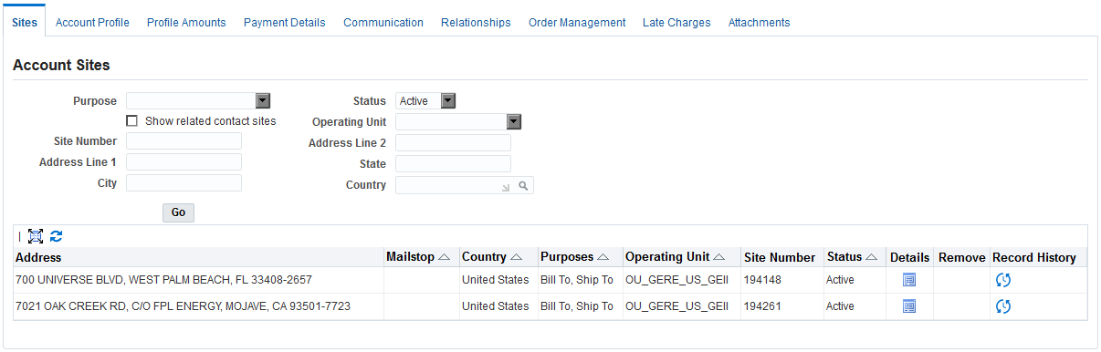

13.1.4 Change the Status to Inactive and click on Save

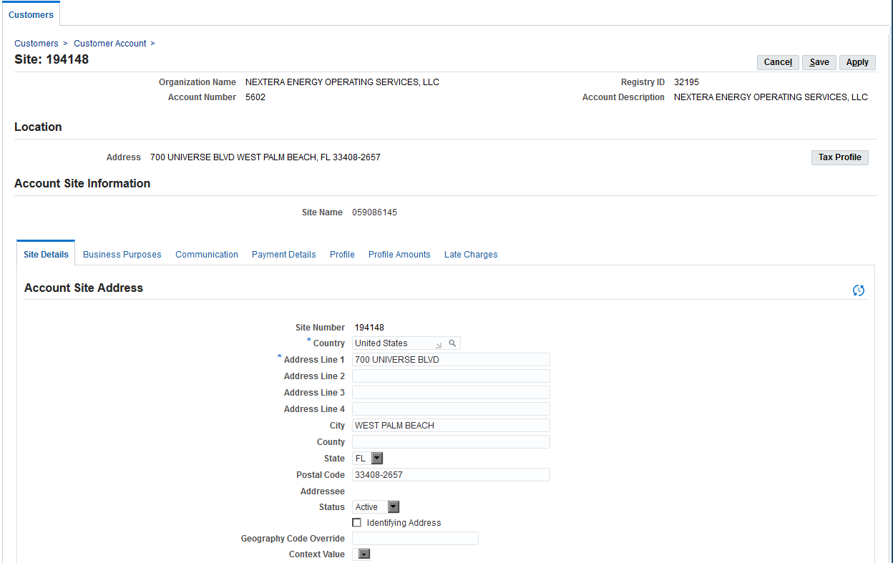

13.1.5 You will receive a confirmation of the changes

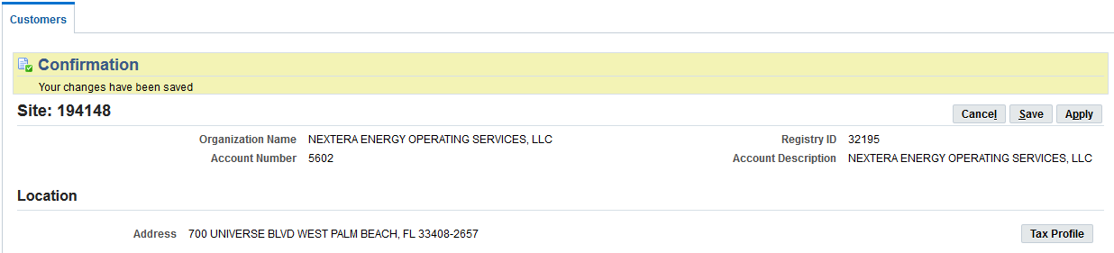

13.2 Account Inactivation

If this is used, none of the sites defined under the Account will be available to create more transactions. Use with caution.

13.2.1 From Customer Maintenance responsibility, search the customer for which you want to inactivate the account

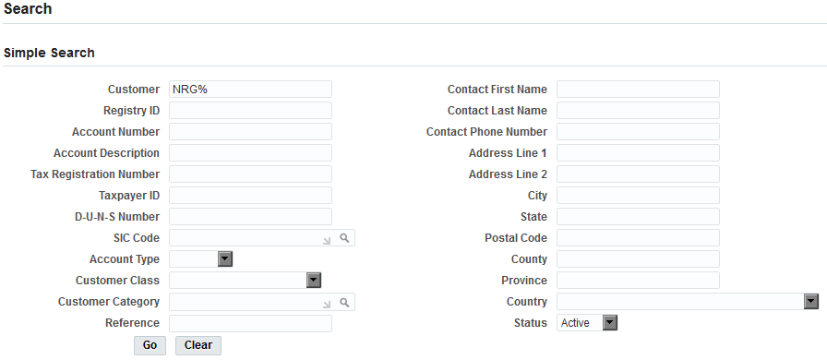

13.1.2 Once in the Results page, scroll down and select the desired account and click on Details at the account level

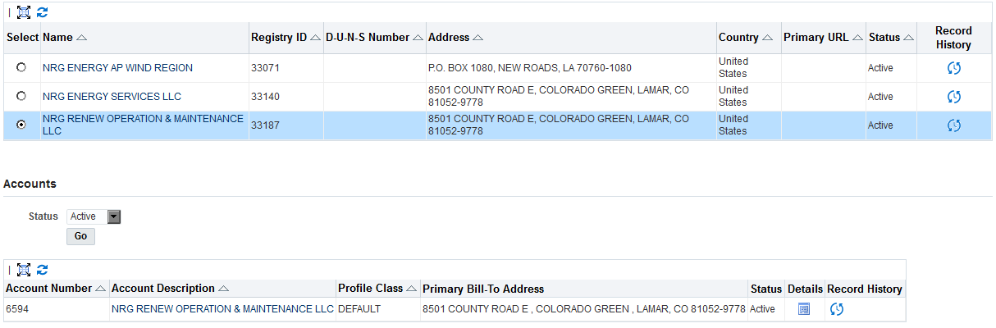

13.1.3 Once at the Account level, change the status to Inactive and click on Save

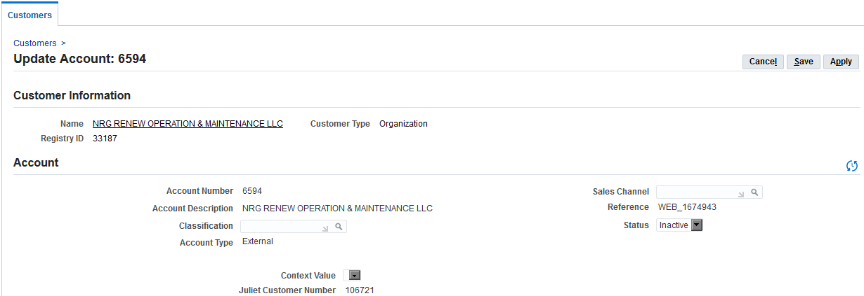

13.1.4 You will receive a confirmation of the changes

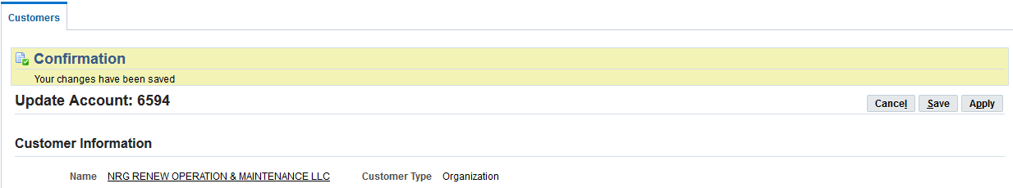

# Open and Closed Items

**Open Items**

|  |  |  |  |
| --- | --- | --- | --- |
| **Id** | **Logged On** | **Observation** | **Logged By** |
|  |  |  |  |
|  |  |  |  |
|  |  |  |  |

C**losed Items**

|  |  |  |  |
| --- | --- | --- | --- |
| **Id** | **Closed Date** | **Observation** | **Closure Comments** |
|  |  |  |  |
|  |  |  |  |
|  |  |  |  |